**INTEGRATION TESTING:**

Integration testing is the second level of the software testing process after unit testing. In this testing, units or individual components of the software are tested in a group. The focus of the integration testing level is to expose defects at the time of interaction between integrated components or units.

**Testing All Functionalities:**

**Test_case-01-> admin_login and admin_menu**

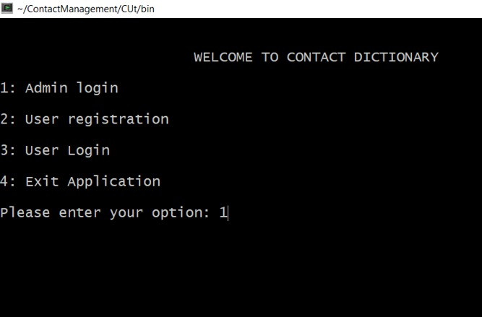

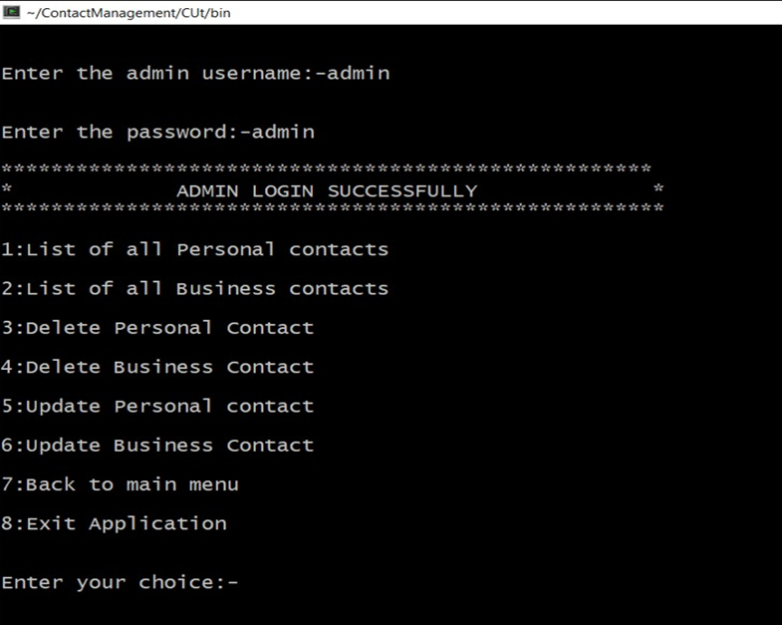

**Test_case-02->user_registration and pass_reset**

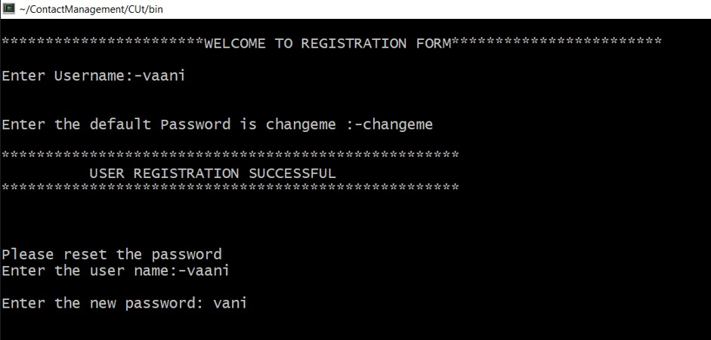

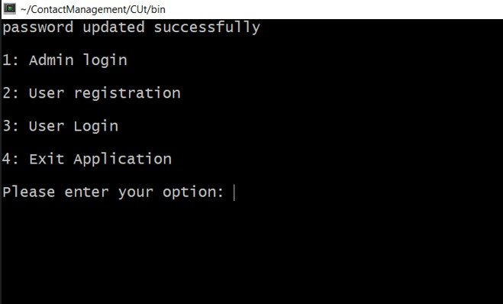

**Test_case-03-> user_login**

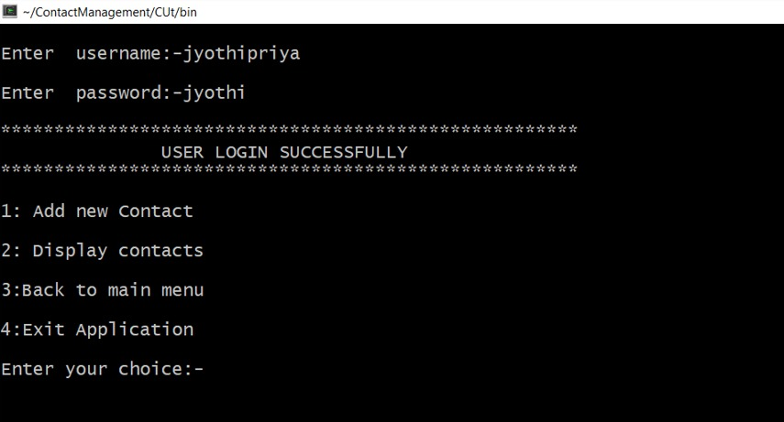

**Test_case-04-> add_new_contact**

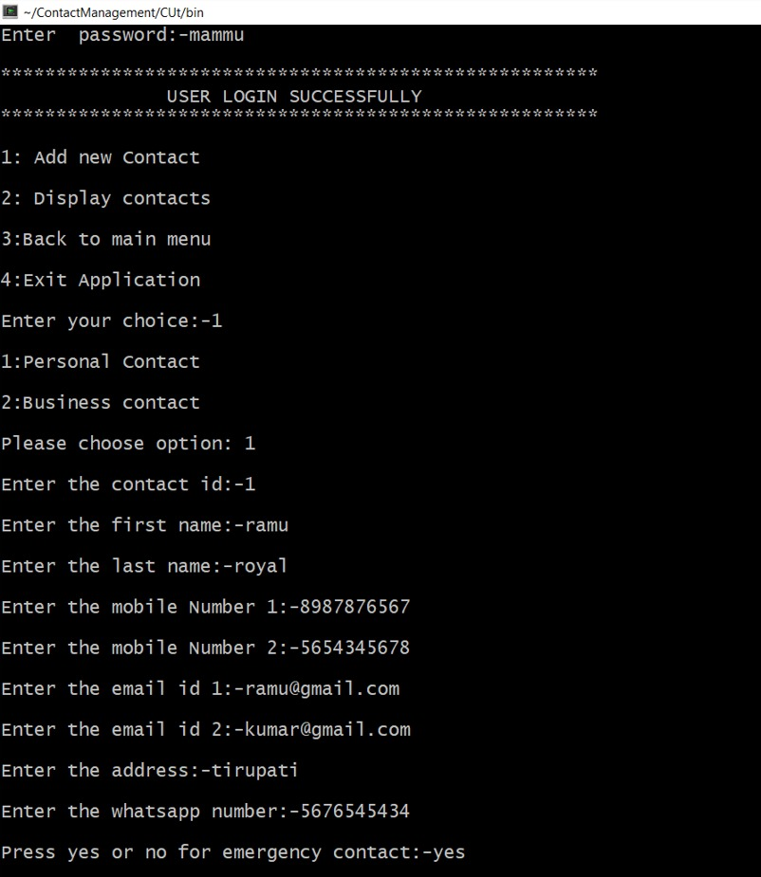

**Test_case-05-> update_contact**

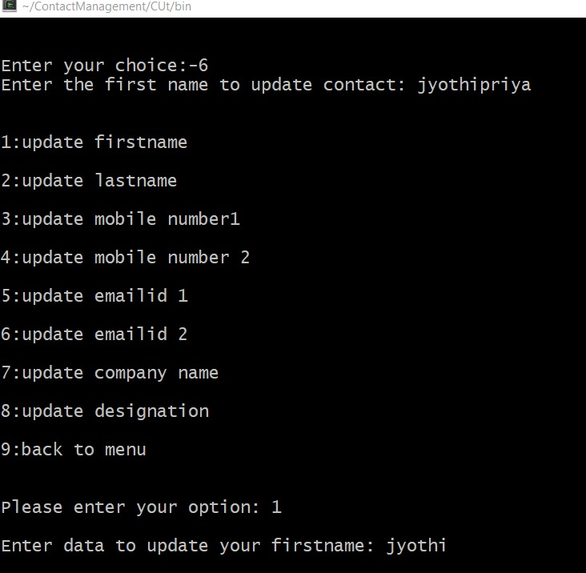

**Test_case-06-> delete_contact**

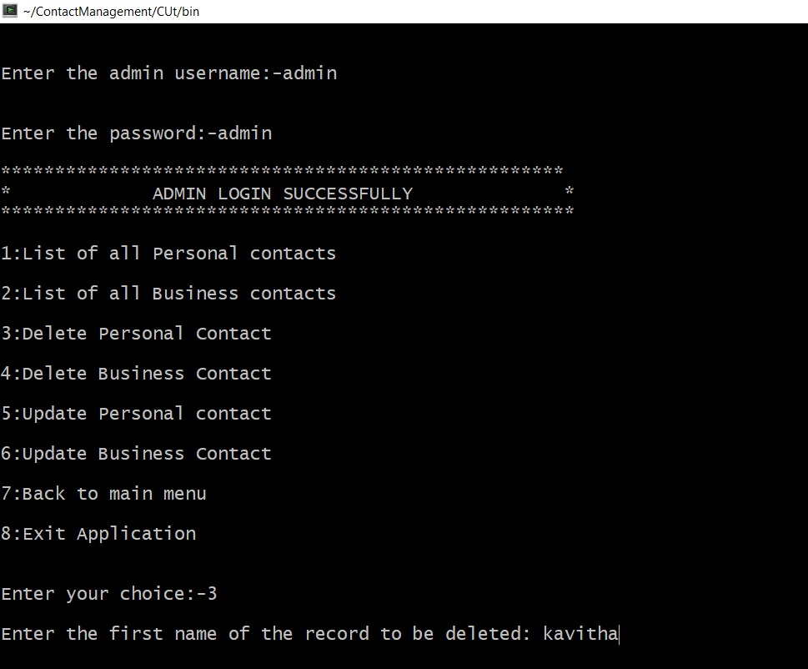

**Test_case-07->List_contact**

